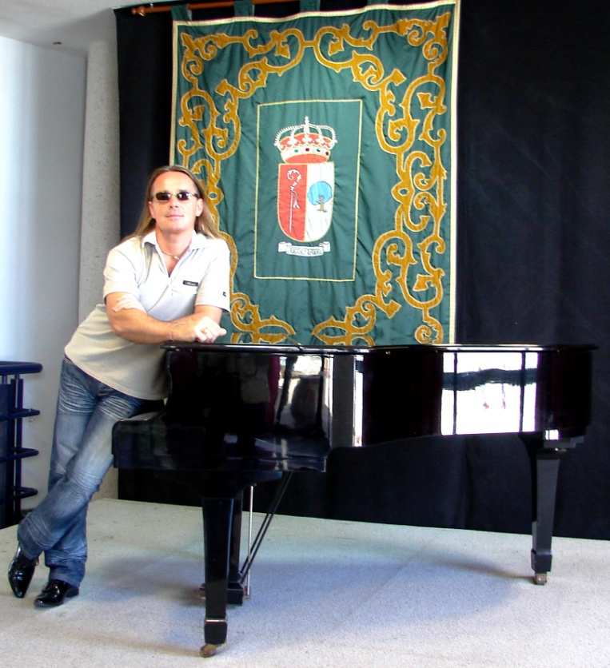

AND REFERENCES

Contact : Paradise Record Production - Tel.: +34 606 389 893, Tenerife (ES) email: aristudios777@gmail.com

***************************************************************************************
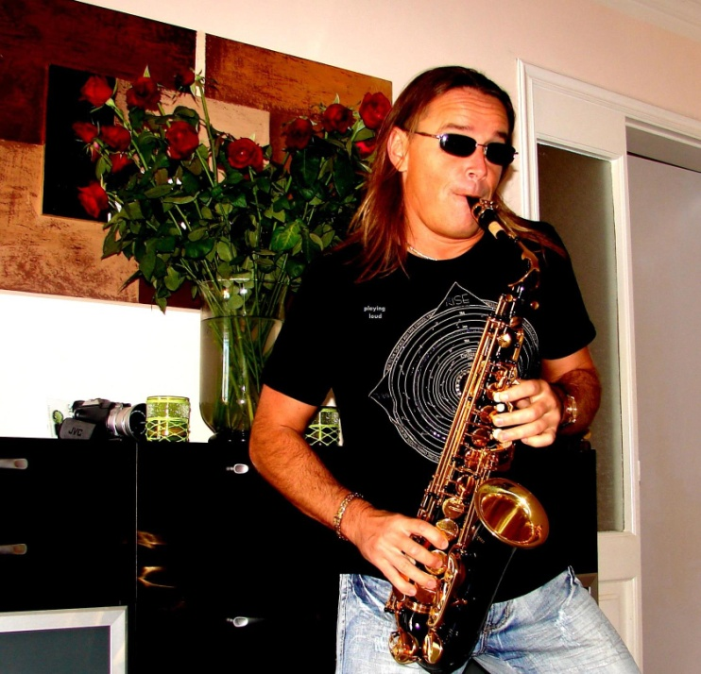

ALEX RUSHIN (Alexey Afanasiev)

Shortly the Biography:
Born 13.08.1971 in Pushkin, Russia, now - resident of Tenerife, Tlf. 652 477 851
Studies:
1977 - 1987 English School in Petersburg
1987 -1991 High School of Music in Moscu MKPU, Russia,
Profile Classes : Percussion, Composition
Profesores:
Alexander Jusupov - Composition, David Felzmann – Percussion
1991 - 1992 Production and co-direction of culture events of of Centre of Art " Russj" in Moscow and meanwhile participation in various musical project in Moscow and in Russia.
3 Place in International Festival in Sochi, Russia with Song "Hello, Moscow"
2 Place in Festival of Young Pop in Gorky Park, with Song "Star Islands"
2 Place in Radio Europa Plus with the Song of L.Timoshenko „Snow Angels“ as the Singer & Performer
meanwhile - Various TV – Shows & Tournees across the Russia.
1992 - December - Invitation from International Youth Christian Assotiation of Germany
for the contract with the own musical project „ Jesus Loves You“.(Itune, Amazone)

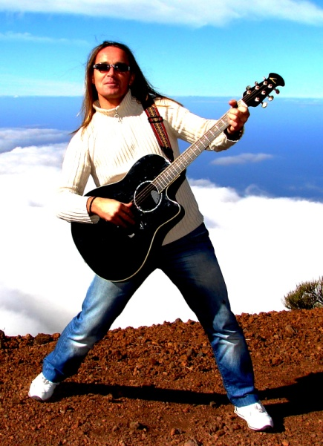 Remote (On Line) Production in Tenerife 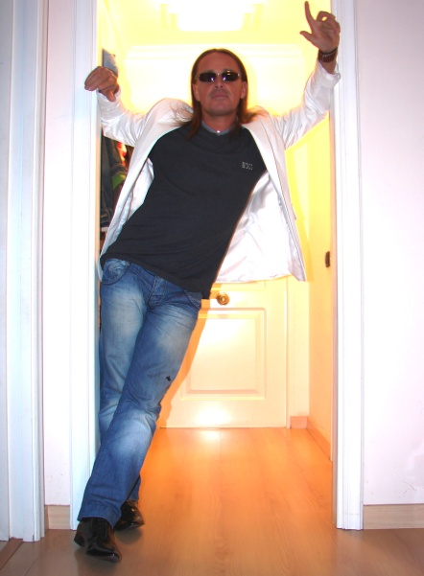 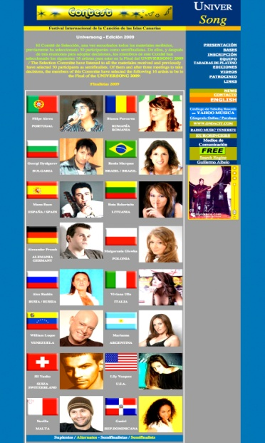 Participant of International events.

During his more than 15 years living in Germany, and since 2004 being bounded with partially
time contract in the local branch of the music Company “KOCH -UNIVERSAL” as a composer.
Charismatic person and performer - Alex Rushin was successfully collaborated with Coryphées of
Pop – as Fancy,Reiner Thielmann, Peter Graf, Alan Silson, Tony Marshall, Andrea Lamar, Ruki Ruki Verh, Belij Orel, Mirage and many others.

"Musikmarket" in August 2004 wrote a laudatory review on the initial page of the Magazine,
Music edition "Activ Sound Studio" (Austria, Landeck) took his song
"Nur Die Liebe" in the pool of their productions for the project
"Ilka und Robert”,whose CD got the top in Austria in the year 2006.

Despite the natural talent, Alex is constantly working upon the improvement of his
creative and musical abilities and talents.

Nowadays In his Vocal Coaching Classes in Tenerife, (Canary Islands) he has developed
and presents his own technology for training the strength and of the voice
during the long-acting performance.

As the owner of the Record Studio and Act-Performer he is involved in many project all over
in Canary Islands, Russia and Europe.

These photos may say more than any words

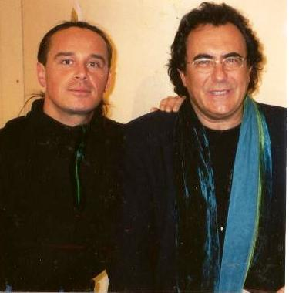 with Albano 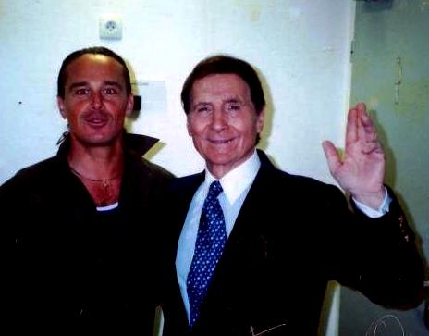 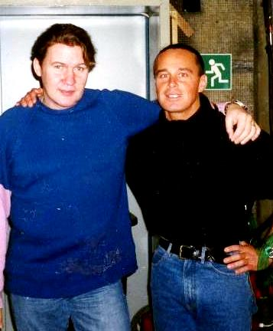 with Jonny Logan

Magazin «Ikarus» wrote:

“With powerful and energetic voice, during his
2 hours performance Alex Rushin, as the winner & participant of many festivals in Europe
and the only Russian residential performer in Canary Islands - represents his own
compositions, popular rock and pop themes of 70s, 80s & 90s, covering songs from Beatles,
Eagles, Deep Purple, Nazareth, Tom Jones, Rod Stewart, Chris Norman and others, making
interesting re-mixes of different Projects and re-mixes of Sting, Dire Straits, Bon Jovi and
many more.
Extraverted and extraordinary Singer Alex Rushin covers events of all sizes and formats:
from very exclusive, up to large scale public events, family reunions, weddings, birthday parties,
anniversaries, corporate events, product presentations, trade fairs, galas, shows on cruises,
hotel and club events, open air concerts, TV & radio concerts and many more.

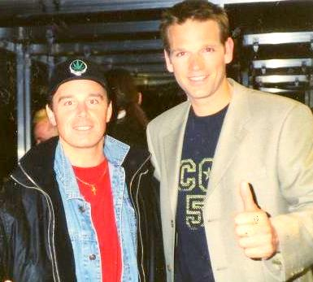
with Kai Boeking Sandra Ahrabian presents AR new CD

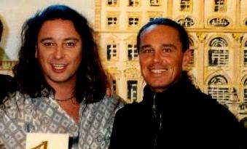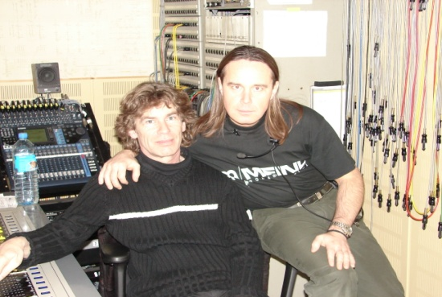
Production with group - Paldauers Production for Bavaria Studios, Munich

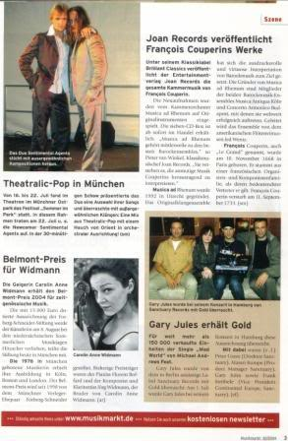 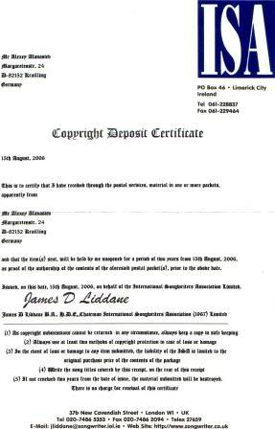 Musikmarket

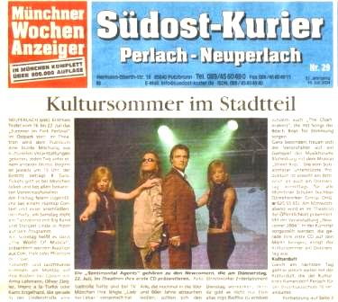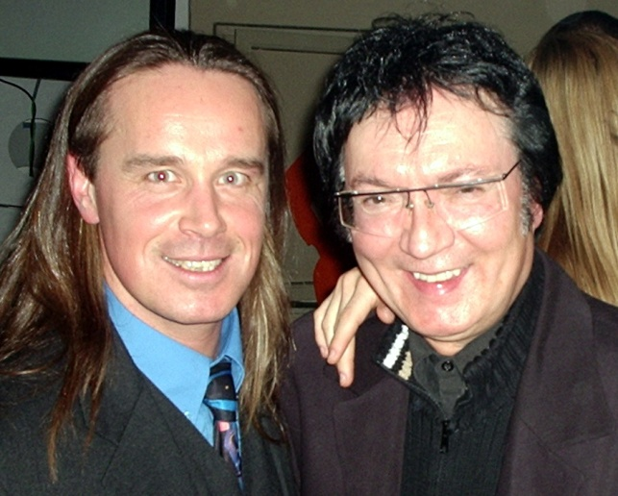
Articles in International Press production with Mr.Fancy, Germany

